1. Download the SQL SERVER 2019 edition from the Microsoft Site

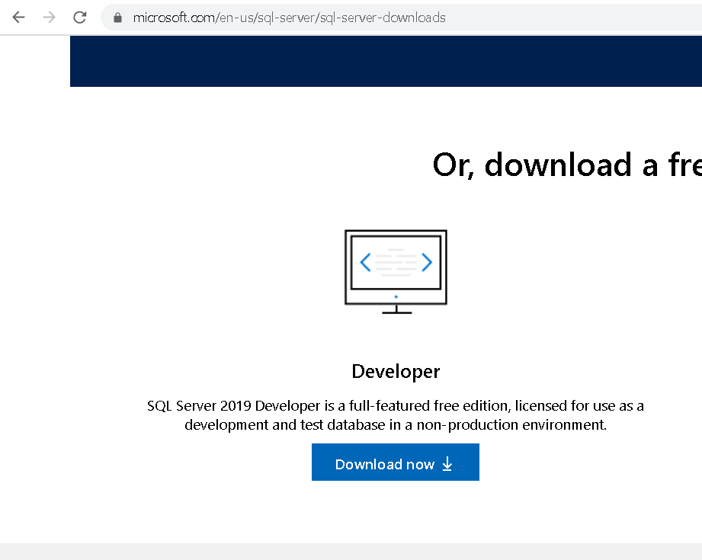

1. You will see in your download location something like below:



1. Double click on the install icon and Select the custom option. You can also download the media file first. I usually prefer the media option so that I can install it later as well:
2. Downloading will start and will take some time based on the internet connection speed:

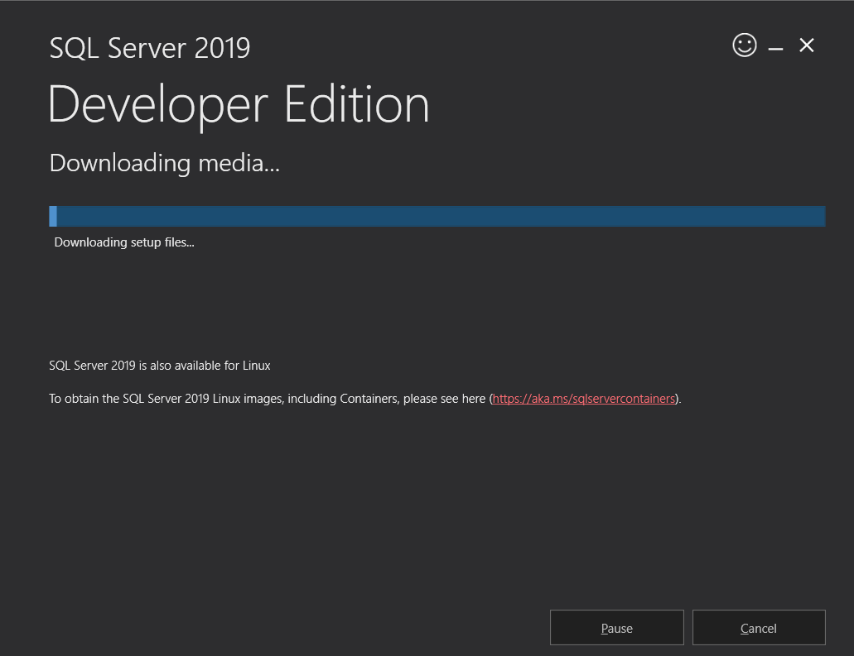

1. Once download is complete you will see a .exe file and .box file as below:



1. Simply click on the .exe file and it will open up the installation center:

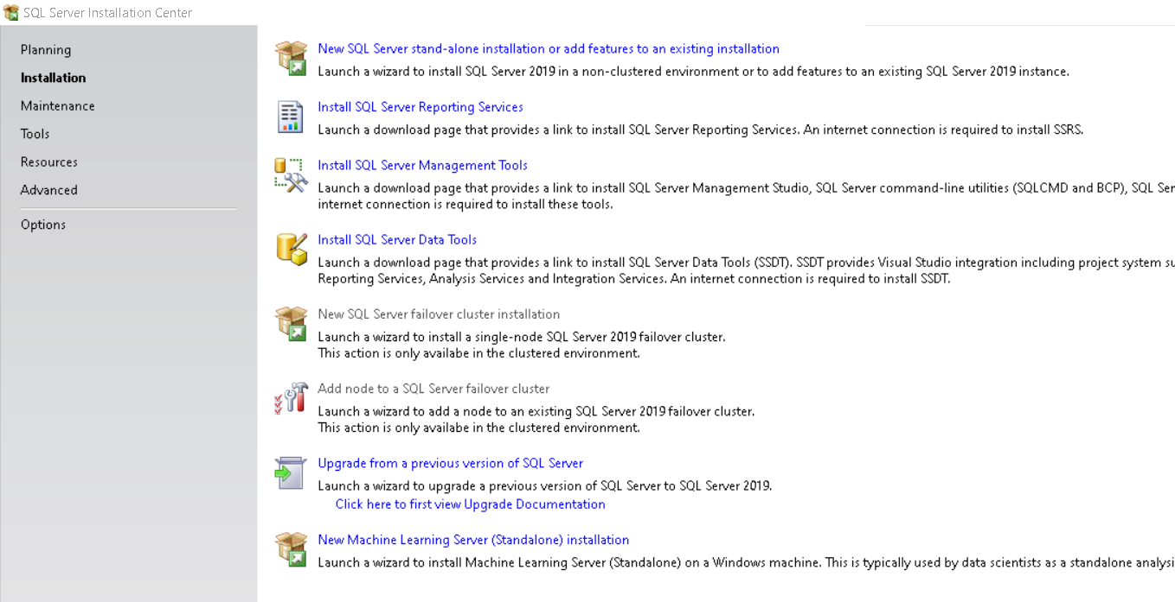

1. Multiple things can be installed from here. Kindly select first option for the fresh installation:
2. Let’s install the default options available as of now, we can add or remove the things later on as well:

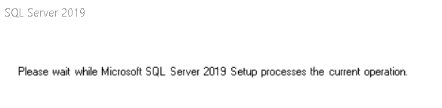

1. Click on Next:

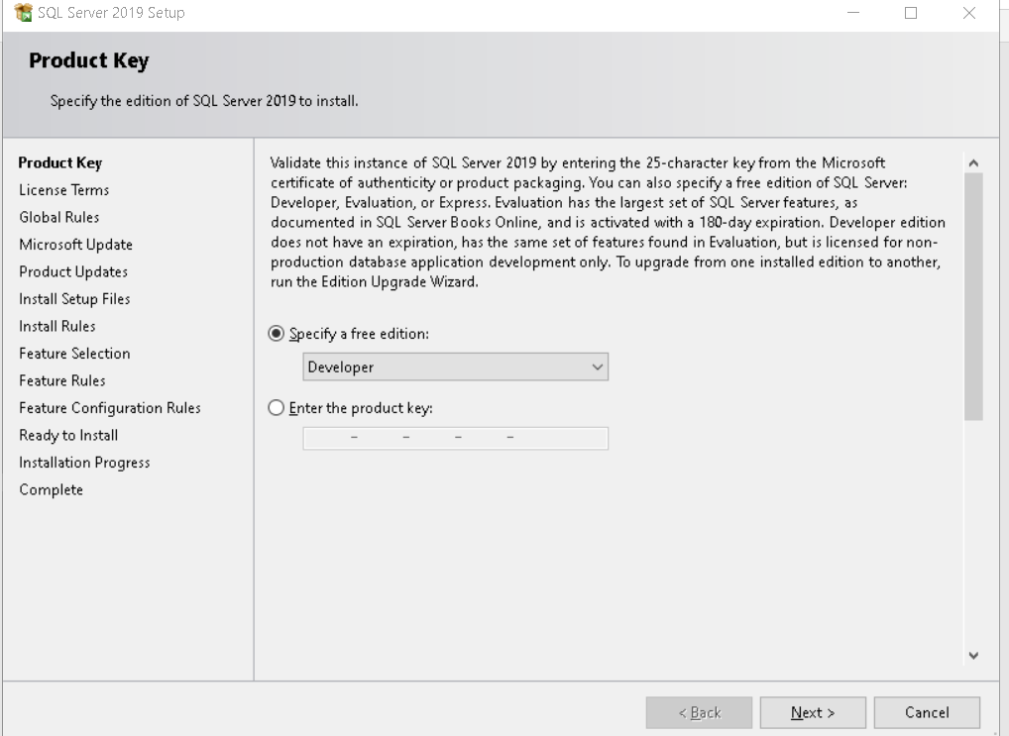

1. Simply click on next and next and below step will take some time:

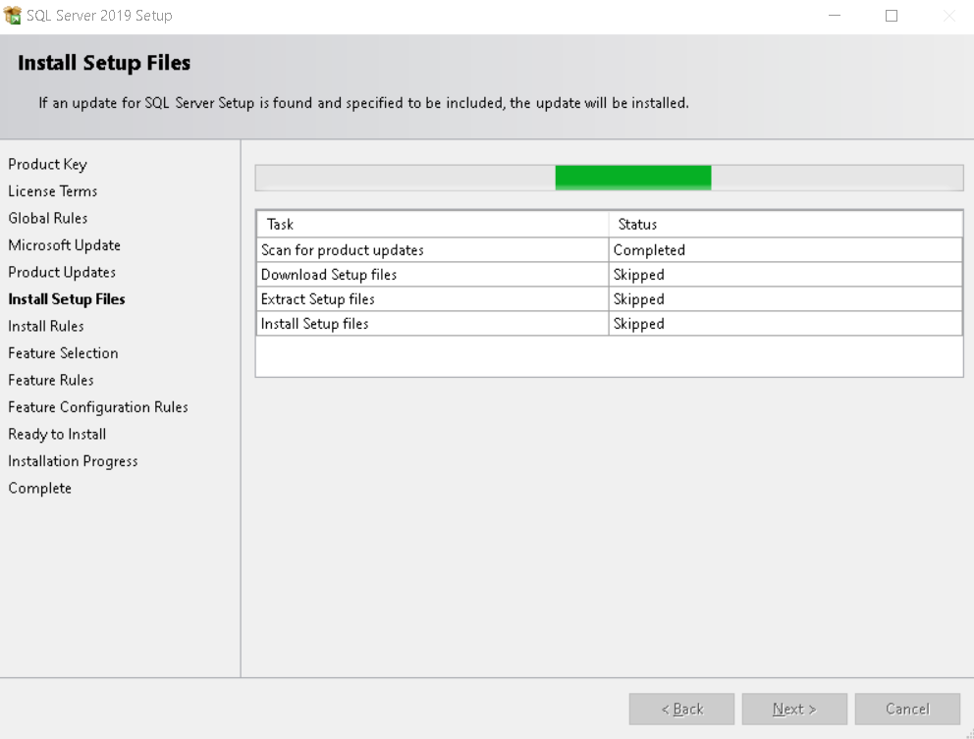

1. Select below options to install the SQL Server. We are selecting specific features only:

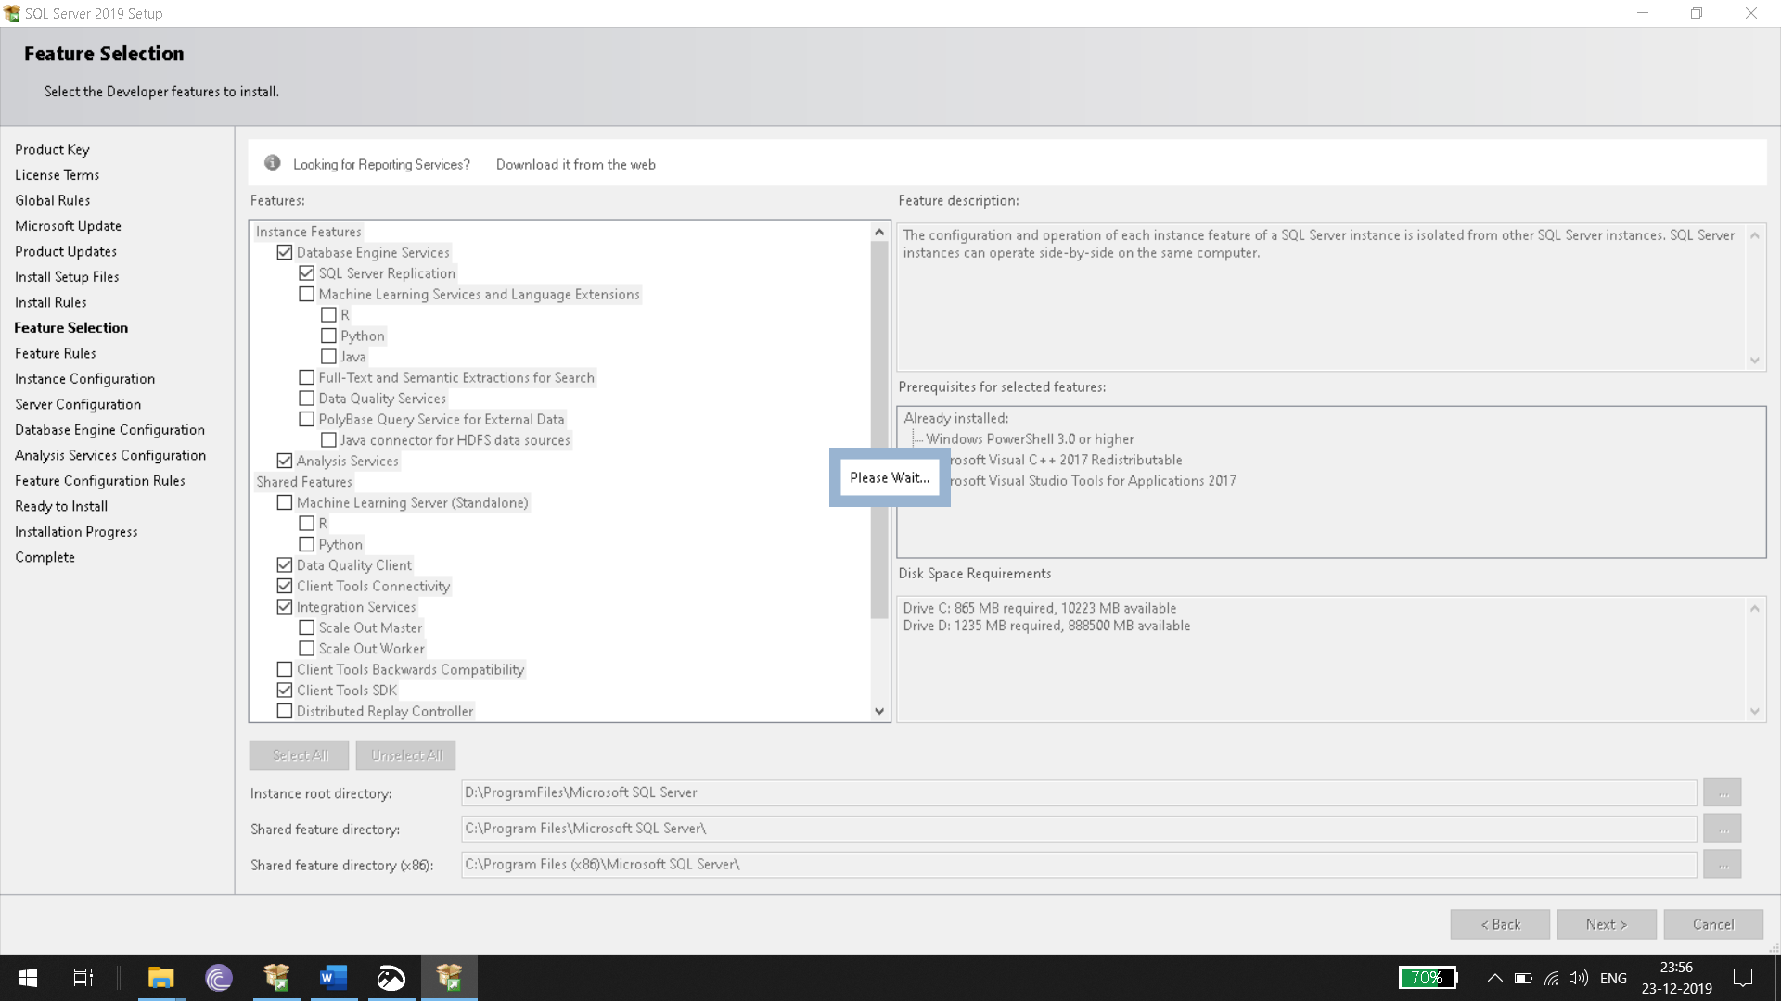

1. Select Default instance

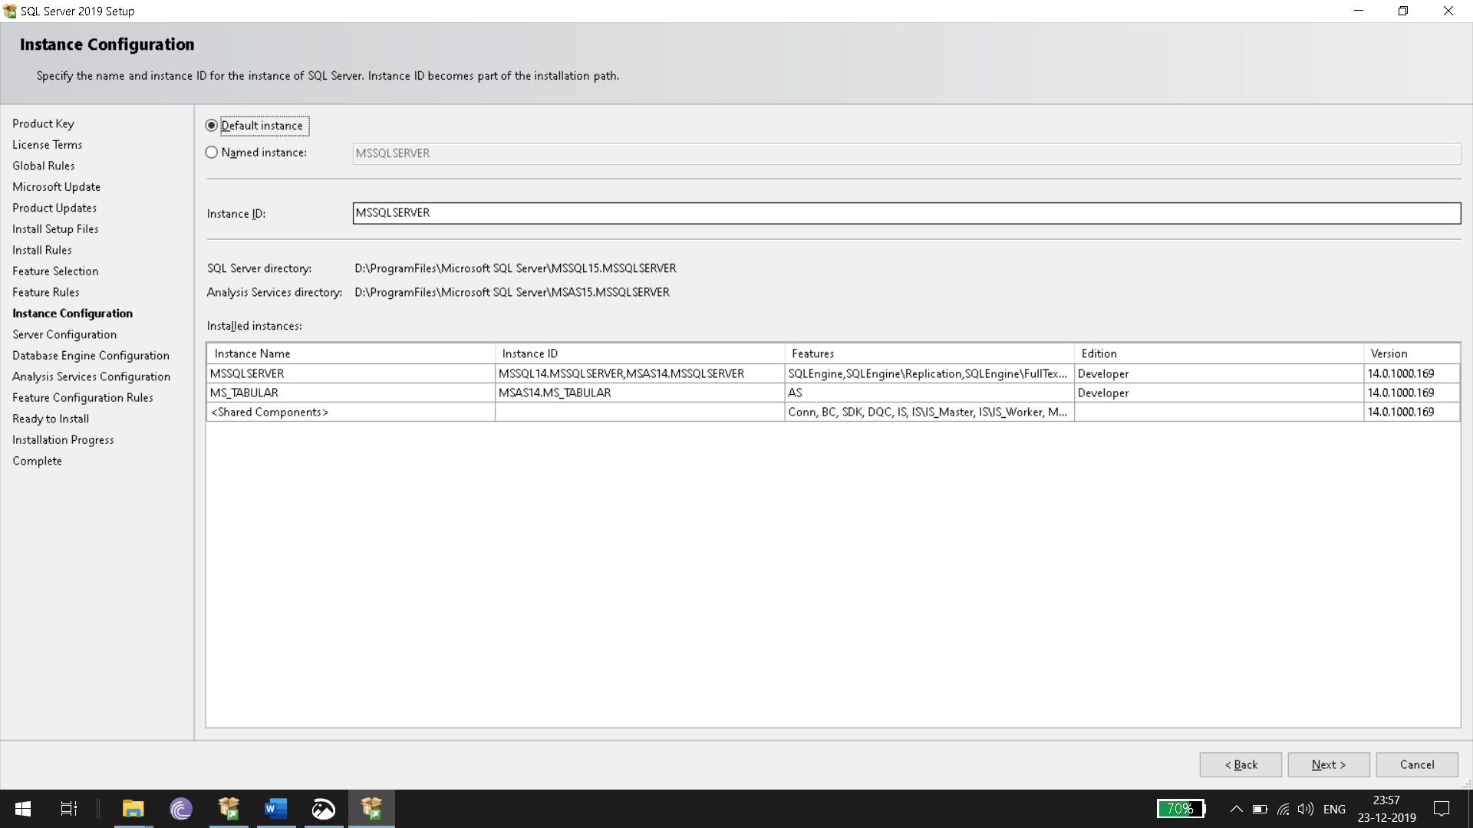

1. Set below as well in default state
2. 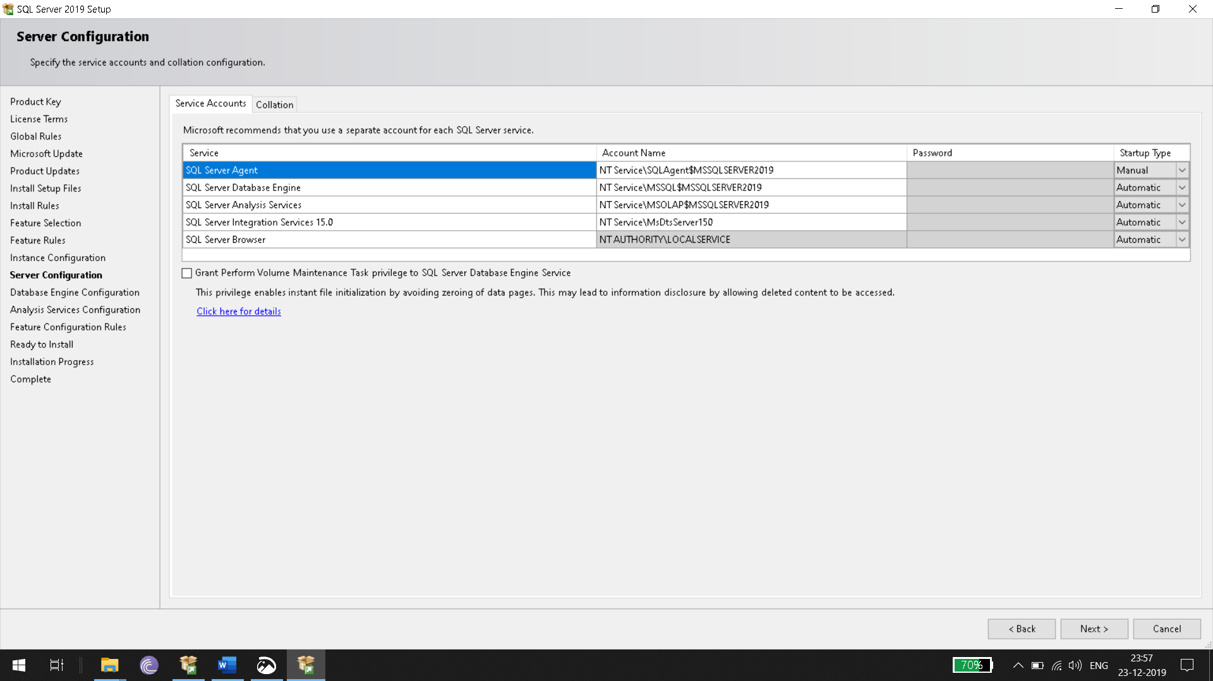
3. Click on add current user for below window:
4. 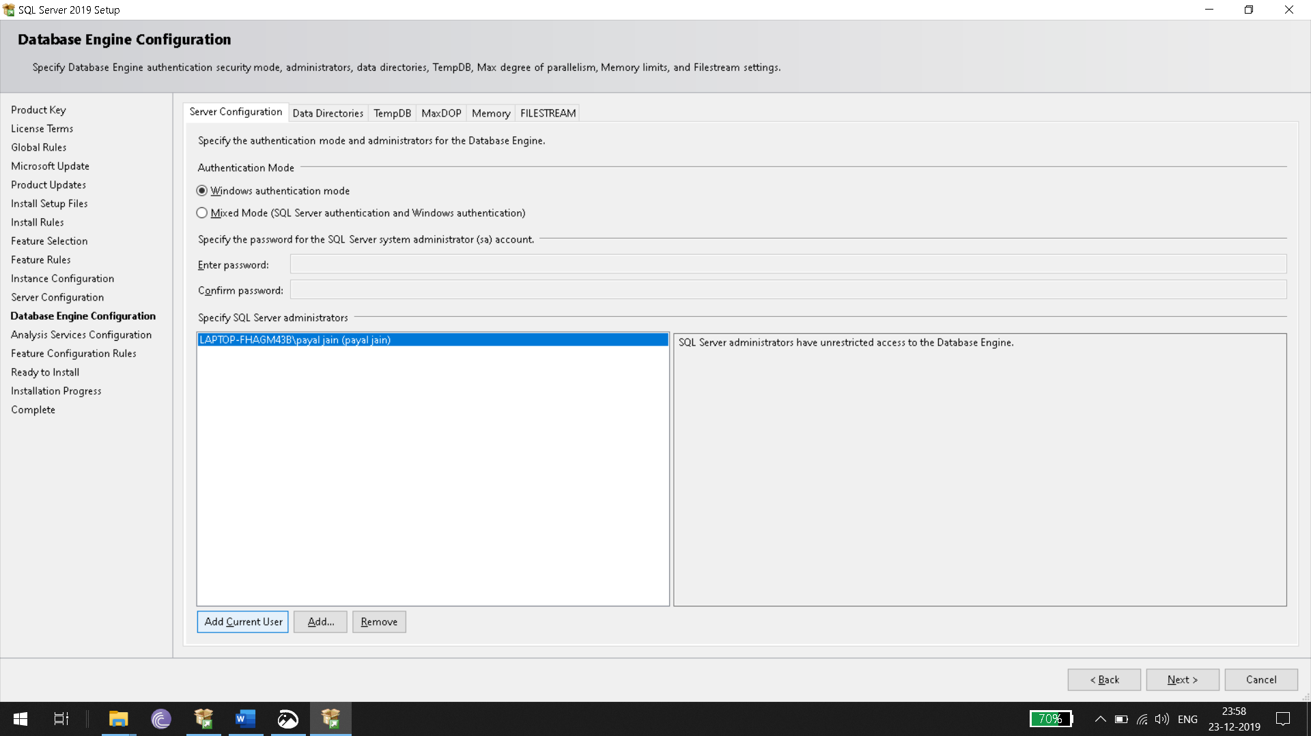
5. You can also follow below Video:
   1. <https://www.youtube.com/watch?v=GdfRDjrQw68>